Assignmnet 9.2

Problem 1:
Create an HBase table named 'clicks' with a column family 'hits' such that it should be able to
store last 5 values of qualifiers inside 'hits' column family.

Solution:
//creating table
create 'clicks','hits'

//adding records with “ip-address ”as the row key
put 'clicks','192.168.1.1','hits:country','1'
put 'clicks','192.168.1.1','hits:state','28'
put 'clicks','192.168.1.1','hits:city','300'
put 'clicks','192.168.1.1','hits:district','700'
put 'clicks','192.168.1.1','hits:people','1000000'

//displaying the contents of the table clicks
scan 'clicks'
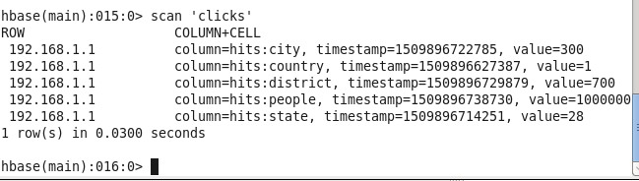

Problem 2:
Add few records in the table and update some of them. Use IP Address as row-key. Scan the table to view if all the previous versions are getting displayed.

Solution:
//Altering the version of the clicks table from 0 to 5 so that it can store the older values
alter 'clicks',NAME=>'hits',VERSIONS=>5

//updating the values of country using ip-address as rowkey
put 'clicks','192.168.1.1','hits:country','2'
put 'clicks','192.168.1.1','hits:country','3'
put 'clicks','192.168.1.1','hits:country','4'
put 'clicks','192.168.1.1','hits:country','5'
put 'clicks','192.168.1.1','hits:country','6'

//displaying the five older versions of country from column hits
scan 'clicks',{COLUMN=>'hits:country',VERSIONS=>5}

